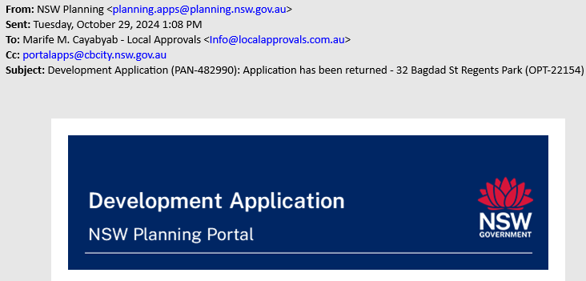

Dear Local,
Your application (PAN-482990) for development at 32 BAGDAD STREET REGENTS PARK 2143 has been returned.
The application was returned on 29/10/24 for the following reason:
1. A survey plan is to be provided to Council which is no older than 6 months from the date of lodgement. Please note that the survey plan must be prepared by a registered surveyor and the registered surveyor number must be shown on this plan and signed by the surveyor.
2. A site analysis plan is also to be provided in addition to the site plan provided.
3. A shadow diagram is to be provided. – NOT NEEDED! PROPOSED IS SINGLE STOREY WITH BASEMENT
4. No neighbour notification plan has been submitted and is to be provided to Council. Please note that the neighbour notification plan must include all elevations of the proposal, as well as any ancillary structure elevations. A site plan must also be provided and no internal details of the proposed development must be shown on the plans. Please note that all of this must be shown on one A4 sheet.
5. The statement of environmental effects provided makes reference to the incorrect councils controls (Shellharbour). Please note that this document must make reference to the relevant controls and legislation.
We are not able to offer an opportunity to make changes as part of this PAN. This is in line with requirements that have been introduced by the NSW Government aimed at reducing development application assessment times and more broadly tackling the housing crisis. Read more about the Statement of Expectations Order here: (https://www.planning.nsw.gov.au/policy-and-legislation/housing/faster-assessments-program/statement-of-expectations-order)
If you wish to submit a revised application, you can click the “Copy to new application” button in the application heading. A new application will then be created with the content from the previous application pre-populated. You can amend all fields within the document to address the reasons this application was returned and will need to upload all required attachments..
You can view the reason for return, details, associated documents when you open the application. The application (PAN-482990) has been moved to the completed work section of your NSW Planning Portal dashboard.
If you wish to submit a revised application, you can click the “Copy to new application” button in the application heading. A new application will then be created with the content from the previous application pre-populated. You can amend all fields within the document to address the reasons the original application was returned.

